**Q1. What is "this" keyword in JavaScript?**

* Objects are the basic building block in javascript.
* This is a special object available in javascript.
* This refers to global object or scope, by default execution context is global.

Example:

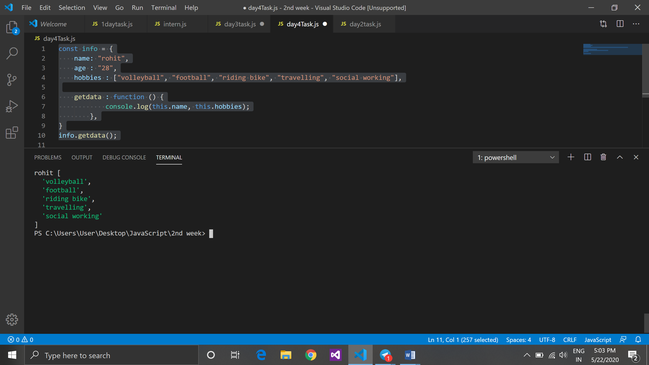

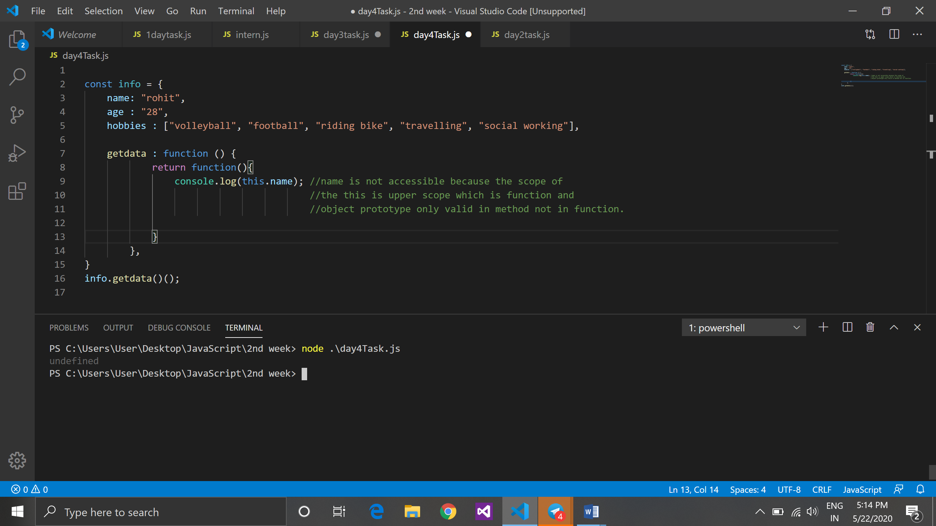

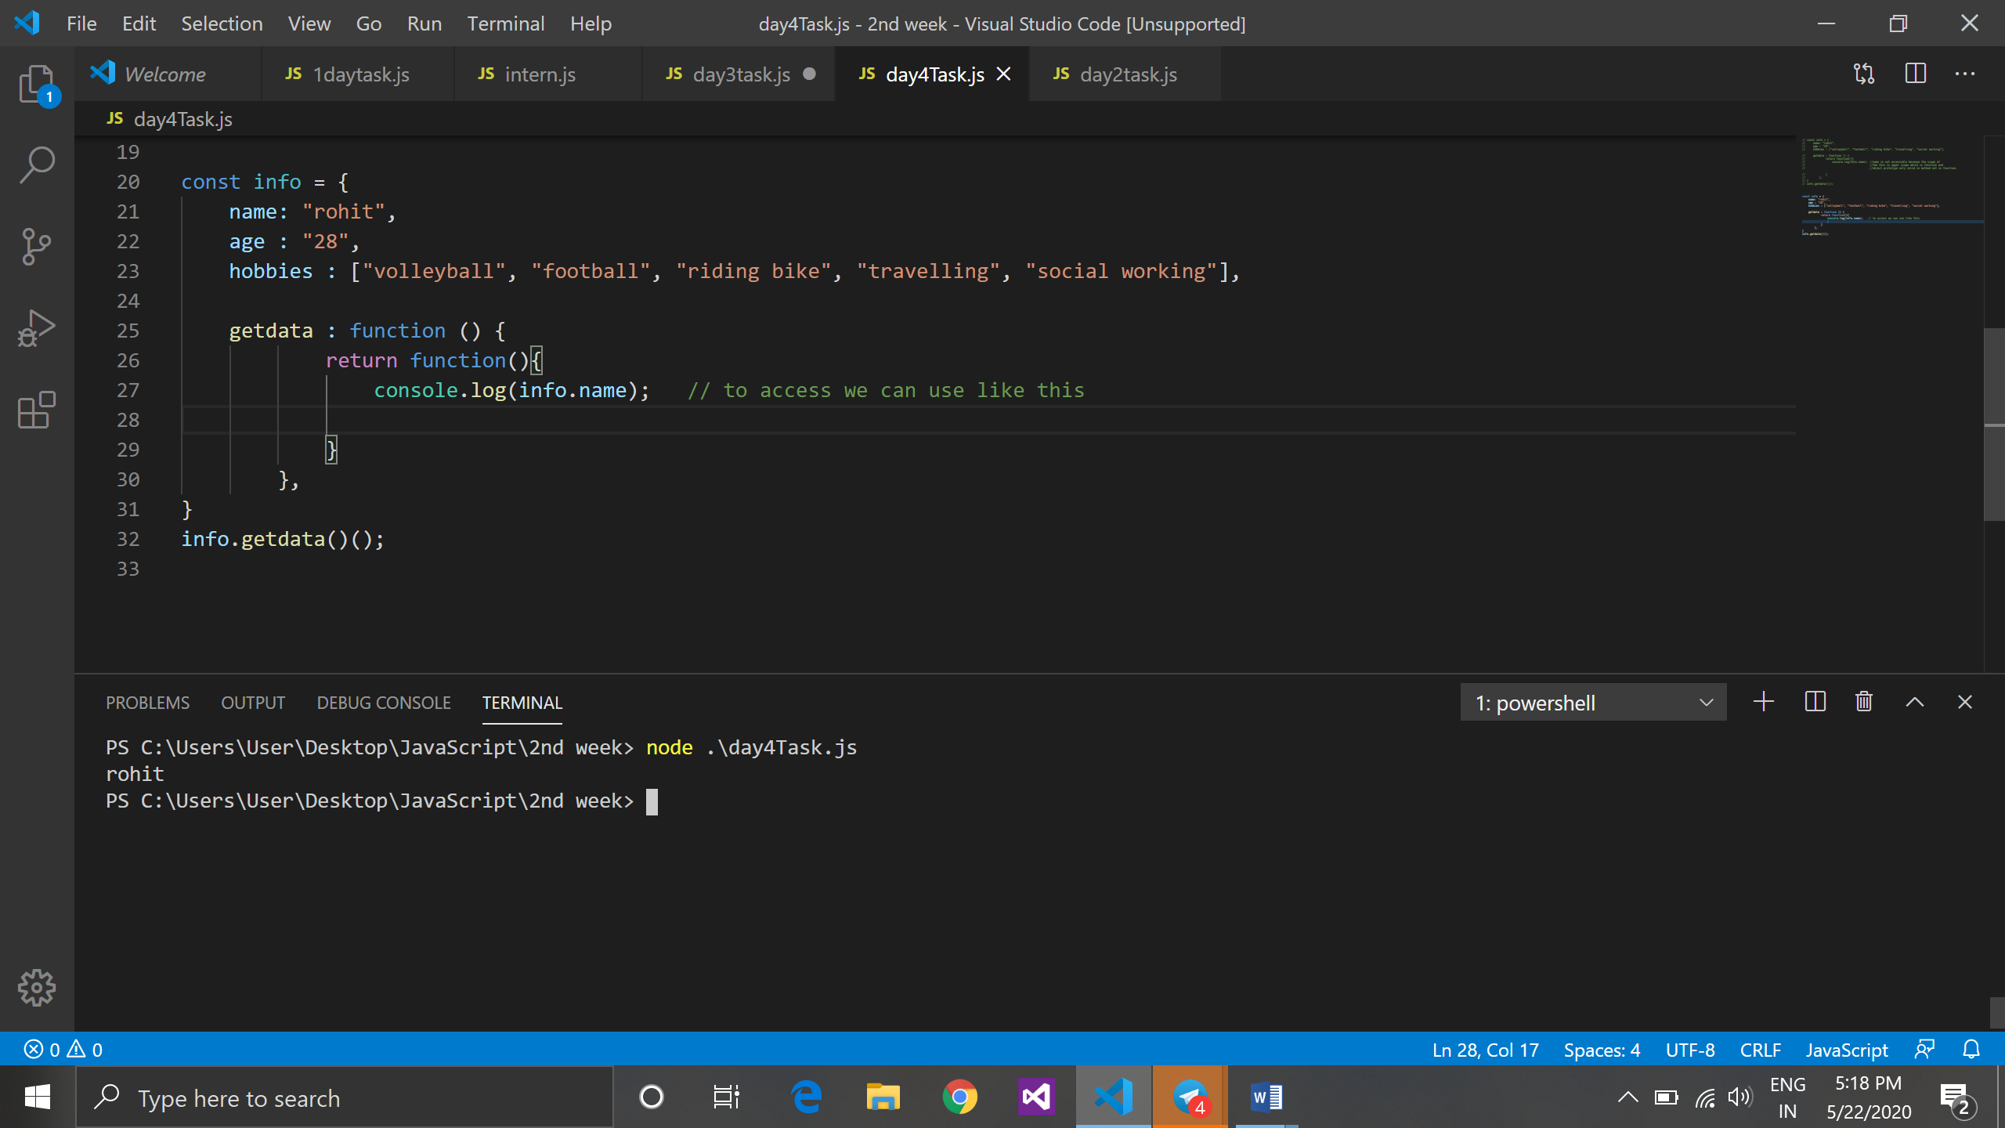

**Q2. What is Prototype in JavaScript?**

* + Javascript is prototype based language.
  + To add method in object variable it become object prototype in javascript.
  + Object prototype is only valid In method not in function.
  + Prototype of object created object and array created array.

**Q3. How can we access word "javascript" here ?**

(a). const arr = ['start', [[['node', 'express', 'javascript'],['react', 'css', 'javascript']]], 'end'];

